December 5, 2023

Zhenyu Fang

Undergraduate Student, Mechanical Engineering

Houston International Institution

Dalian Maritime University

**Subject: Letter of Transmittal**

Dear Sir/Madam,

This is capstone team “SCI TOP 1” consisting of members: Zhenyu Fang, Jifeng Zhou, Jiaheng Zhang, Xinyue Zhang, Sen Gao. We are submitting our progress report of the capstone project entitled “Intelligent marine buoyancy platform system”, in which the described progress covered from Augst 10 to December 5 in 2023.

The platform system we want to develop is utilizing the renewable energy to achieve various functions such as target detection. Up to now, we have done the research of the background, design of the structure and completion of the first draft of the modeling.

We hope that some practical suggestions would be offered after you have read the attached progress report.

Sincerely Yours

Zhenyu Fang

Intelligent marine buoyancy platform system

TEAM: SCI TOP 1

TEAM MEMBER:

Zhenyu Fang

Jifeng Zhou

Jiaheng Zhang

Xinyue Zhang

Sen Gao

ADVISOR: Dr. Zhaogui Wang

Covered Time period: 2023.8.29 – 2023.11.5

Fall Semester

Submitted: 2023.11.5

**Abstract**

Marine monitoring equipment is of great significance to the exploitation and utilization of marine resources. However, due to the frequently changing conditions and the inconvenience of signal transmission in the ocean, the traditional marine monitoring equipment is hard to carry out real-time monitoring of the sea conditions in a specific area for a long time. Hence, this project aims to develop an intelligent offshore buoyancy platform system that utilizes renewable resources in the ocean for self-power supply. The expected functionality is the target detection, which can be applied in offshore farming, marine pollution monitoring and etc. Improved from traditional offshore buoys, this device will incorporate two main parts, where the first one is balancing equipment, and the other one is energy harvesting device. The former device is for greater target detection, and the later one will collect the tidal, solar and other forms of power. Furthermore, structural optimization will also be implemented to realize high strengthen and lightweight characteristics. Briefly, the design process will involve CAD modeling, finite element analysis (FEA) to identify weaknesses and areas for improvement, fabrication of a prototype, and experimental validation in a pool. Ultimately, the project will deliver a physical model of the system with supporting experimental verification and simulations.

**Table of Contents**

Content

List of Figures & Tables iii

1. Introduction & Problem Statement iv

2. Statement of Work, Deliverables, Validation vi

2.1 Statement of Work vi

2.2 Deliverables vi

2.3 Validation viii

3. Specifications ix

4. Milestones and Expected Results x

4.1 Milestones and Expected Results for 2023 x

4.2 Milestones and Expected Results for 2024 xi

5. Progress Descrption xi

5.1 Milestones Completed xii

5.2 Milestones Remaining xii

5.3 Problems Encountered or Anticipated xiii

6. Schedule xiv

7. Budget xiv

8. Conclusion xv

9. Reference xv

**List of Figures & Tables**

**List of Figures**

Figure 1. We are committed to the monitoring mission of the transparent ocean and want to seek new breakthroughs in it v

Figure 2-3. Multi-functional collection of water floating platform design by Solidworks. v

Figure 4. Initial modeling of 3D models vi

Figure 5. Analysis of overall sinking and floating movement of submerged vi

Figure 6. Snorkeling process two-dimensional analysis diagram vii

Figure 7. Shock-absorbing jellyfish structure 3D modeling diagram. viii

Figure 8. schedule presented by gantt chart.. xiv

**List of Tables**

Table 1. Specifications of each part ix

Table 2. Estimated user cost xiv

1. **Introduction & Problem Statement**

This progress report details the work items for Multi-functional collection of water floating from date9.1 to date 7.1, assigned to Team six as part of the requirements for MECE 4340: ME Capstone design for the 2023-2024 school year.

Ocean observation plays a fundamental role in studying and utilizing the ocean, as well as in safeguarding marine rights, developing marine resources, warning against marine disasters, protecting the marine environment, strengthening national defense, and seeking new development opportunities. The ocean holds vast and rich renewable resources, which have great potential in addressing energy demands and various challenges in coastal environments. In this project, our goal is to develop an intelligent offshore buoyancy platform system that harnesses the abundant renewable resources in the ocean. Unlike traditional offshore buoys, this innovative system not only provides self-power generation but also offers advanced functionalities including target detection, support for offshore aquaculture, and monitoring of marine pollution.

Traditional nearshore buoys have limitations in power generation and functionalities. They rely on external power sources and lack the capability to perform complex tasks. Therefore, a new approach is needed to design buoyancy platforms that can overcome these limitations and fulfill the requirements of sustainable energy production and multifunctionality.

The main objective of this project is to create an intelligent offshore buoyancy platform system that effectively harnesses various renewable resources in the ocean. To achieve this goal, we will draw inspiration from nature and incorporate biomimetic locomotion mechanisms into the design. By mimicking the efficient movements of natural organisms, the platform will be able to navigate flexibly in the ocean and perform targeted detection tasks.

Additionally, the system will support nearshore aquaculture activities by providing a controlled environment for cultivating various marine species. This will contribute to sustainable food production and reduce reliance on traditional land-based cultivation methods. Furthermore, the platform will play a crucial role in marine pollution monitoring by collecting data and analyzing water quality parameters[1].

Power generation is a key aspect of the proposed system. The challenge lies in generating sufficient and stable electricity to sustain the platform's operation and support its multifunctional capabilities. To address this challenge, we will draw inspiration from existing tidal and solar power generation devices and adapt their principles to design an efficient power generation mechanism that can seamlessly integrate into the buoyancy platform.

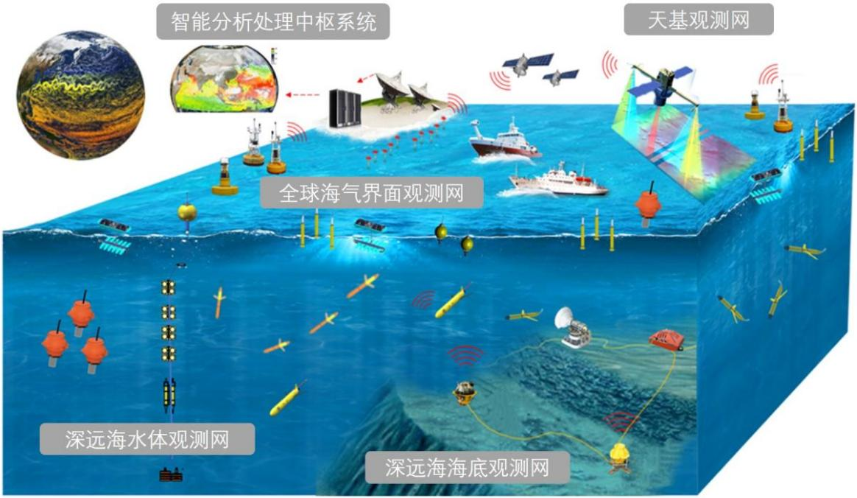

Figure 1. We are committed to the monitoring mission of the transparent ocean and want to seek new breakthroughs in it

To ensure the success of the project, we will follow a comprehensive design process. We will start with computer-aided design (CAD) modeling to create a detailed virtual representation of the system. This will allow us to optimize the design and identify potential weaknesses before proceeding further. Finite element analysis (FEA) will be employed to simulate the system's performance under various conditions and make corresponding design improvements.

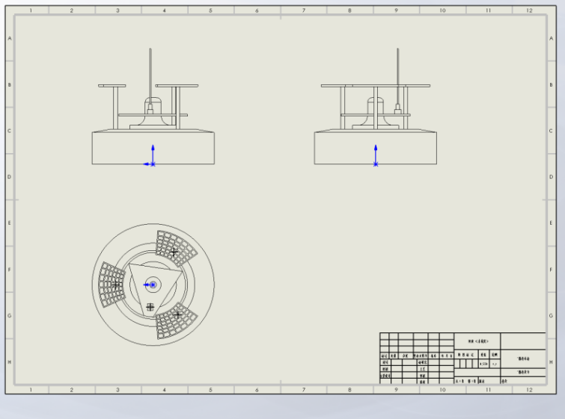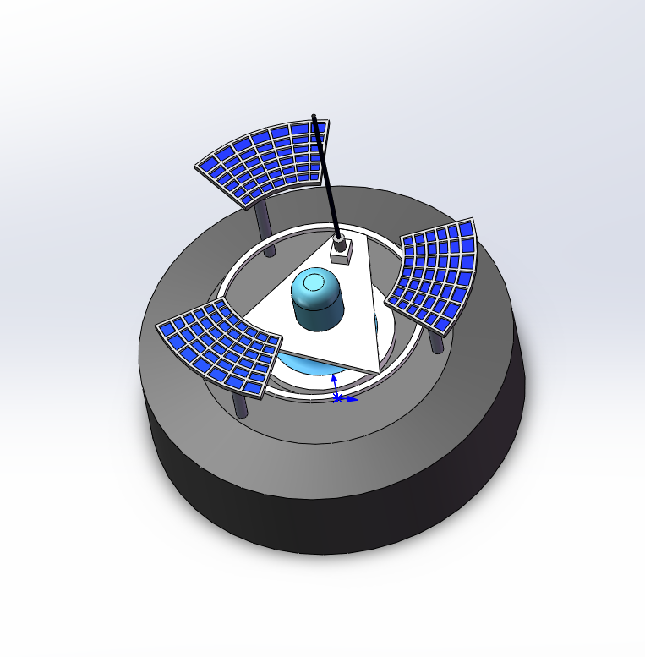Figure 2-3. Multi-functional collection of water floating platform design by Solidworks.

Once the initial design is validated through finite element analysis, a physical prototype will be manufactured. The prototype will undergo extensive experimental testing in controlled pool environments to validate its functionalities, power generation ability, and overall performance. The data collected during the experimental validation stage will provide valuable insights for further refinement and optimization.

By the end of the project, our team aims to deliver a physical model of the intelligent offshore buoyancy platform system supported by relevant experimental validations and simulation results. The successful development of this system will pave the way for sustainable energy production, advanced practices in nearshore agriculture, and effective monitoring of marine pollution in the marine environment.

The project is from date9.1 to date 7.1,2023-2024 school year.

1. **Statement of Work, Deliverables, Validation**

**2.1 Statement of Work**

The goal of this project is to develop an intelligent offshore buoyancy platform system that utilizes renewable resources in the ocean for self-power supply and accomplishes the function of target detection. The ideal outcome is that the device can realize detection during regular period and the energy harvested can support the self-contained operation of the system.

**2.2 Deliverables**

We have Realize 3D topology optimization (TO) codes in MATLAB. Realize the basic MATLAB-ABAQUS-Python joint-simulation of 3D TO codes with 8-node equilateral element

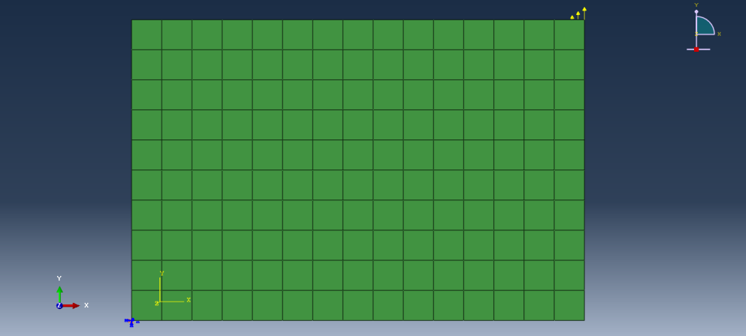

* Figure 4. Initial modeling of 3D models

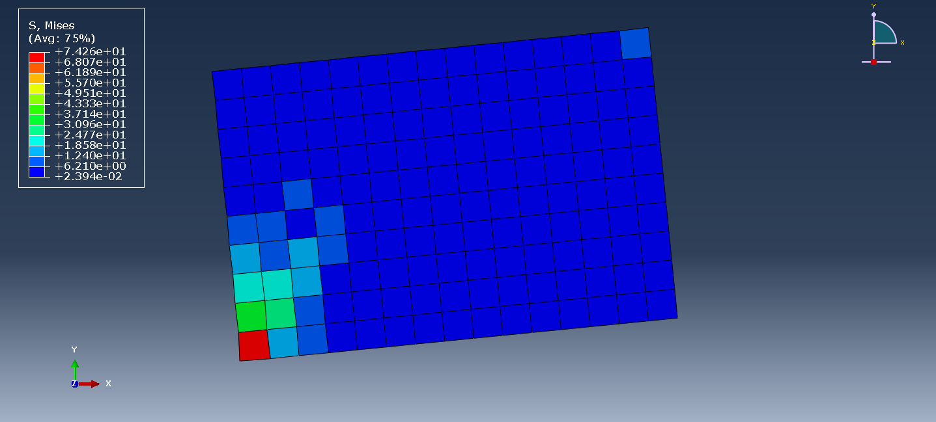

* Figure 5. Analysis of overall sinking and floating movement of submerged platform on water surface

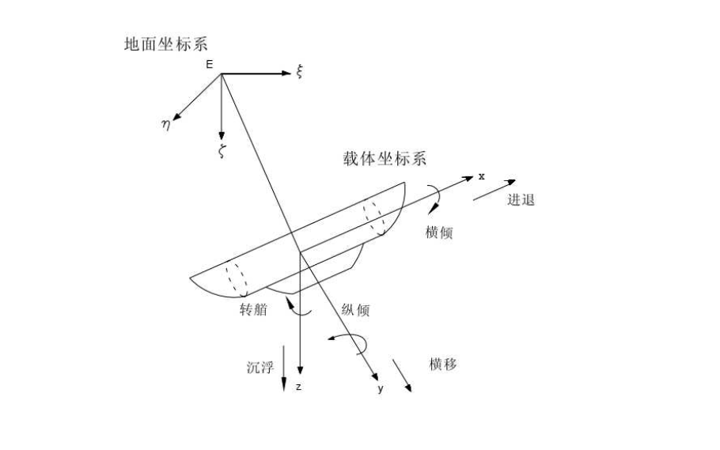

* Figure 6. Snorkeling process two-dimensional analysis diagram

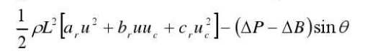

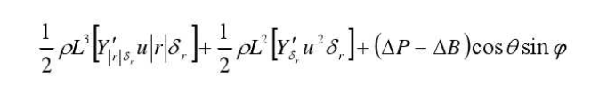

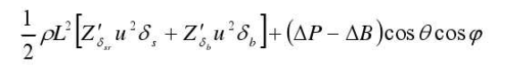

We also model and analyse **two classically occurring folded** structures using satellite folded solar panels as the object of study.

* And Completing the previous 3D design sketches for the force feedback structure, the initial purpose of maintaining the balance of the pontoon was largely achieved.
* Read articles on ocean waves for marine resource utilization and start designing how to collect and convert ocean wave signals.

* Figure 7. Shock-absorbing jellyfish structure 3D modeling diagram.

**2.3 Validation**

After the assembly of the device frame and all connected components we carry out the validation programme.

* To validate the finite element analysis we will use force transducers, strain gauges and proximity probes. The strain gauge will be connected to the highest stress bar and a known force applied to the bar. The strain readings and displacements measured with the probe will allow for the calculation of the internal stresses within the frame. The calculated results will be compared to the simulation results and the yield stress.
* Validation of the overall equipment soundness will include validation of wave power generation using COMSOL. The stress-strain distribution and other mechanical properties of the test members under certain conditions have been analysed using ABAQUS theoretical data. Loads will be applied to the initial and final configurations and the corresponding outputs will be recorded.
* To test the mechanical properties of the main platform, we will use impact experiments and sealing tests on 3D printed components in the pool. The power supply capability of the device is tested by recording the operating time of a small light bulb of a specific power. Perform buoyancy tests on some of the components. A certain amount of mass and weight is added to the surface of the parts to reflect the buoyancy of the parts.
* A pool, impactor, and a small light bulb with a specific power of pounds will be required to verify that the device is reasonably active on the surface of the water.
* Validation of the floating platform will require a tape measure, force transducer, and plotting software. Force transducers will be connected to the inputs and outputs of the transmission. Loads will be applied to the initial and final configurations and the corresponding outputs will be recorded. The results will then be recorded and the graphs will be output.
* The control of the sinking and floating motion must consider the stability and robustness of the control system. The requirement for stability is due to the complexity of the environment in which it operates; robustness mainly compensates for modelling uncertainty and variability of the operating environment. For the floating and sinking system, a simplified simulation model can be built. It is subjected to external forces in the vertical direction including gravity G, buoyancy B, fluid resistance to platform motion and thrust generated by thrusters ∑. Here a piston airbag buoyancy system is used so there is no project. The buoyant motion of the platform is driven by a change in buoyancy called residual buoyancy.

1. **Specifications**

|  |  |  |  |  |
| --- | --- | --- | --- | --- |
| **Table 1 Specifications of each part** | | | | |
| Part | Size(m³)  L*w* h | Voltage（V） | Power（W） | Note parameter |
| solar panel | 0.5m*0.5m*0.01m | 24V&5V | 80W | 120AH battery |
| camera | 0.2m*0.2m*0.2m | 5V | 1W | I= 0.2A |
| Jeston nano | 0.2m*0.2m*0.2m | 5V | 10w | I= 2A |
| network bridge | 0.4m*0.3m*0.1m | 24V | 6W | I= 0.25A |
| anemometer | 0.05m*0.04m*0.03m | 5V | 3W |  |
| aspirator pump | 0.09m*0.04m*0.07m | 12V&24V | 10w | Made of stainless steel |
| Circular floating platform | D = 0.6m  H = 0.3m | none | none | Acrylic sheet material |

We firstly determined the size of the finished product through group discussion, and looked up and read the relevant literature to roughly determine the amount of water required to achieve snorkelling, thus determining the volume of the air reservoir at 0.09m * 0.04m * 0.03m. Considering the overall weight, we chose this size to facilitate the installation, and also determined the power of the supporting air pump to be 10w.

The size of the camera part is chosen as 0.2m * 0.2m * 0.2m, which can maximise the collection of maritime information and also meet the infrared function. The information can also be clearly obtained at night.

The structural size of the bridge part is 0.4m * 0.3m * 0.1m and the power is 10w;

The wireless network connection between the floating platform and the shore base station is based on the power supply requirements of the three organisations mentioned above.

The solar panels need to power the bridge and the camera, from which we need to output 24V and 5V respectively. In terms of collecting energy for the purpose of being able to supply the bridge and the camera, we determined the size of the solar panel needed to be 0.5m * 0.5m0.5m (the larger the area the more solar energy will be collected). The power of this solar panel is 80w, and its supporting battery capacity is 120AH, which can achieve the purpose of the camera can also operate at night.

1. **Milestones and Expected Results**

**4.1 Milestones and Expected Results for 2023**

* Task1: Study articles on the mechanics of bionic structures of jellyfish

Solving of Task1: Studying the jellyfish bionic material, by reading these completed research designs, it can be illustrated from the literature theoretical point of view that the structural model of jellyfish bionic can again help our gimbal to reduce the impact of the sea currents to a certain extent and maintain a certain attitude position. And the research report also gives its practical scenarios and some basic theoretical formulas, finite element analysis, etc., which can help us to better design the jellyfish bionic shape.

* Task2: Study of materials for underwater power supply circuits

Solving of Task2: In the study of underwater power transmission, I need to take into account the complexity of the underwater situation and the factors affecting it, such as the underwater pressure, the degree of corrosion of seawater, the efficiency of power transmission and the choice of wire materials.

* Task3: Energy options and utilization patterns

Solving of Task3: Our project is a multi-functional integrated platform, which needs to achieve the stabilization of the gimbal and be able to videotape in rough seas. How to cope with complex weather, how to realize surfacing and diving. Whether the array structure is stable, waterproof, and coping with extreme conditions. Energy: Despite the availability of many renewable resources, the forms of energy available to us are still limited, including tidal energy and solar energy[2]. In addition, the mass of components, such as accumulators, should be carefully considered in balance with buoyancy. In addition, the power consumption of electrical equipment needs to be considered.

* Task4: Learn general head structure and general motor control algorithm

Solving of Task4: The basic control of stm32 microcontroller and brushless motor can be carried out from various websites. After learning the basic control principle, we first designed a simple PTZ through 3D printing and 3D modeling for testing. Finally, some sensor units are added to the learning, and the sensor feedback is added to the control system to achieve closed-loop control.

* Task5: Research on waterproof and anti-corrosion of PTZ.

Solving of Task5: For the current general head has not been able to be used well at sea or in the sea, the reason is that it is difficult to do a good job of waterproofing, preventing water vapor and preventing seawater erosion to improve the service life. In this regard, we can learn by reading some articles about the deck materials of the ship support and some effective waterproof coatings, and we can also choose our best way by purchasing the waterproof materials on the market and conducting experiments.

* Task6: Design Selected Prototype Fabricated

Solving of Task6: Solution draft assembly and system diagrams. Consult relevant books to determine the feasibility of the equipment and analyze the balance angle of buoyancy and sinkage

**4.2 Milestones and Expected Results for 2024**

In the spring of 2024, we expect to complete the overall Marine floating platform, which includes the visual identification system, the PTZ system, the sea surface lifting system, the solar power system, and the anti-wave system of the floating platform.

* Visual identification systems: need to be able to identify different types of vessels on the sea.
* PTZ system: Through the pid control of the motor, the camera can be relatively stable in the sea.
* Sea level lifting system: It is necessary to start self-protection in the face of more severe conditions and sink the equipment underwater.
* Solar power system: Need to provide power input to other parts of the float.
* Floating platform anti-wave system: reduce the impact of waves on the floating platform and judge the surrounding environment.

1. **Progress Descrption**

**5.1 Milestones Completed**

As of now we have completed the corresponding modeling in our team, 3D modeling for the overall model, and passed the teacher's approval. Secondly, we have solved some of the problems that existed in the previous phase, first of all, for maintaining a stable attitude of the device in the sea, we gave up the previous idea of adding force feedback models, and used the solution of adding annular spring coils and anchors to help the device to reduce the fluctuations caused by the impact of water currents. In terms of material selection, considering the sinking function of the device, we need to make the density of the device material close to the density of water, so we chose a lighter acrylic sheet material.

In terms of energy utilization and collection, we use foldable solar panels to help the overall device to realize energy conversion and collect solar energy into electricity. The shape of the solar panel is foldable to help the device to collect more solar energy. Secondly, steering wheels are installed underneath the solar panels to help the panels adjust their position for collecting solar energy at different times of the day.

In terms of device settling, we use pumping and suction to help the device perform sinking and floating actions. And a pumping chamber is designed at the bottom of the device to realize this function. And in this process, some quantitative calculations are carried out to ensure that the design results have a theoretical basis and data support.

In the part of sea surface monitoring, we finally use a 1080p definition camera to observe the sea surface in real time, and use a bridge to transmit the collected data to help the device to determine whether the device is sinking or analyze the sea surface data in conjunction with the subsequent program.

In terms of the overall topology optimization of the device, we have achieved a simple optimization of the overall device, reducing unnecessary design structures and performing simple mechanical analyses. The topologically optimized static load distribution diagrams are presented to show the main stress points of the device so that the design of the device can be improved.

**5.2 Milestones Remaining**

In terms of sea surface location and information sensing, the problem still exists is that it is not possible to find a suitable mathematical equation to approximate the process of modeling the sea impact, which means that the device is not able to efficiently transform the sea impact data after it has been collected and process the electrical signals converted from this friction data to derive the possible weather conditions on the surface of the sea. Secondly, it is decided that a critical value should be set when the device is triggered to dive, and when the contribution of all the parameters reaches a certain critical value, the device will dive. However, how to make the device receive the command to ascend after the dive, which means how long should the interval of data collection be. This is a difficult problem at the moment.

In the device dive function and energy collection, the current problem is to select a more efficient, energy-saving dive method, in the beginning of the design of the airbag selected as a sinking method to achieve, but in practice, a sinking consumes the device's power is relatively large, the current use of solar panels to collect the power is not enough to support the device to complete the sinking action. In the next step, we plan to set up a power storage device to collect additional solar power for the next sinking action.

In the part of observing the sea surface, the problem we have now is that the weather or other conditions may affect the clarity of the sea surface observed by the camera, which cannot provide effective data. The second problem is the effectiveness of data transmission, whether the data collected from the sea surface observation should be sent in real time or at intervals.

In terms of topology optimization, only the static force is tested to optimize the load distribution of the overall device, but the impact caused by seawater is a dynamic force in reality, so the previous simulation results are not very convincing. Secondly, topology optimization should expand its research scope, and in the actual situation, it should add corrosion resistance optimization, dot matrix optimization, fatigue optimization and other aspects to improve the optimization structure.

**5.3 Problems Encountered or Anticipated**

In the future we will try to improve the performance of the device as much as possible, e.g. we can add a high power capacitor for storing electricity to help the device to realize the sinking action, or maximize the use of solar panels to collect electricity. In the process of wave data analysis and observation of the surface of the device, so that in the case of data analysis and processing can help to combine the observation of data, directly and effectively derived from the current period of time the weather conditions of the sea surface. This can be used to assist passing ships or other testing centers in taking preventive measures. In terms of topology optimization, we combine a variety of optimization methods to analyze the fatigue level while analyzing the load force, which helps to improve the overall structure of the device. We hope that the final device should be able to meet our initial design requirements.

1. **Schedule**

In this schedule, we think the more difficult time is in the winter vacation. In the winter vacation, you need to complete your own part in detail, and do a detailed model diagram and integrate these models together. This is a big challenge for us in the winter vacation, each in his own home. The solution we propose is to use some online communication software such as zoom meeting and solidwork's "pack and go" function to achieve online project promotion, so as to better assembly and verification of parts after returning to school.

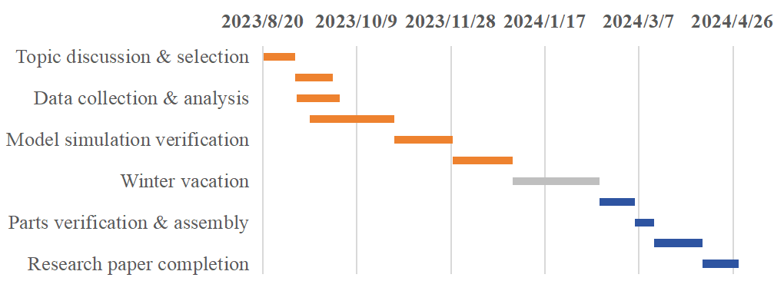

* Figure 8. schedule presented by gantt chart.

1. **Budget**

The following is our budget for each equipment.

|  |  |  |
| --- | --- | --- |
| **Table 2.** **Estimated user cost** | | |
| Part | Budget (RMB) | Path |
| Solar camera photovoltaic power generation equipment | 788 | https://m.tb.cn/h.5iwERNO?tk=jgf9W2ReA92 CZ0001 |
| Anemometer | 99 | https://m.tb.cn/h.5RmiUSG?tk=Cns7W2x6pqJ CZ3457 |
| Air pump | 112.7 | Internet, buy |
| Gas tank | 95 | Internet, buy |
| Camera | 238 | https://m.tb.cn/h.58uOs4h?tk=fePaW2ToDyV CZ0001 |
| Jeston nano | 1479 | https://m.tb.cn/h.5iHt6r4?tk=RrYhW2TNfMo CZ0001 |
| Network bridge | 484.28 | https://m.tb.cn/h.5RR0xu6?tk=2sYyW2TPh3z CZ0001 |
| Total | 3298.98 | Note: it is the biggest expense |

The maximum budget value of our project should be five thousand yuan, and we compare the water robots in the same situation, probably the water apparatus with our function can be up to 20,000 yuan RMB, and the lowest can be up to 4,000 yuan RMB. And our project has the characteristics of multi-functional inheritance, has a smaller size and higher cost-effective. And because we rely on Dalian Maritime University, we can have more resources for maritime co-operation. Therefore, after comparing many aspects, we think the maximum budget value of this project should be five thousand RMB.

Our costs are high mainly because of the high value of the electronic components themselves, or because we tend to buy semi-finished products for processing rather than doing all the processing and assembly ourselves. If the project wants to gain more revenue, I think we can find a partner to work with after expanding production to get the best price.

Regarding the question of how to benefit from the project, since we are multi-functional and integrated, we are ready to cooperate with multiple companies upstream and downstream to become a lookout for offshore exploration. Promote in coastal cities, not only can detect the sea surface environment, detect the breeding situation, but also can carry equipment to detect radioactive substances and so on, the future application prospect is broad.

1. **Conclusion**

Up to now, our team has completed the corresponding modelling work, and the 3D modelling of the overall model has also been completed and passed the teacher's review. For energy utilisation and collection, we used foldable solar panels instead of the origami structure we chose before. A steering wheel was installed underneath the solar panel to help the solar panel adjust its position. In terms of device sinking, we used pumping and suction to help the device perform the sinking and floating action. To achieve this function, we designed an extraction chamber at the bottom of the device, which was a significant change to the structure and initial preconception.

All budget expenditures were made as usual, with no difficulties or major changes. As far as the programme is concerned, we are a little slower than expected. However, we will be ramping up the work over the winter break to stay on or ahead of schedule.

1. **Reference**

[1]项珏,邵进兴,李福生等.基于视频的视觉航标巡检与分析系统[J].广州航海学院学 报,2021,29(03):41-45.

[2]王超. 微小型卫星光伏发电和磁力矩器组件的研究与设计[D].浙江理工大 学,2023.DOI:10.27786/d.cnki.gzjlg.2022.001057

[3] ACS Nano 2020, 14, 6, 7092–7100Publication Date:June 5, 2020

[4] Yuming Lai, Jiahua Ma, Honggui Wen, Huilu Yao, Wenjuan Wei, Lingyu Wan, Xiaodong Yang; High-precision wave height detection of triboelectric nanogenerator by using voltage waveforms and artificial neural network. J. Appl. Phys. 14 September 2023; 134 (10): 104502.